# INTERNAL CONNECTOR



At the digital logic level, internal connectors serve as vital conduits for interconnecting key components within a computer system. These connectors, such as SATA, PCIe, and DIMM slots, adhere to standardized interfaces tailored for specific functionalities. For instance, SATA connectors facilitate data transmission between storage drives and the motherboard, employing pins dedicated to data, power supply, and communication protocols. Similarly, PCIe slots cater to expansion card connectivity, allocating separate lanes for data and control signals, ensuring efficient communication between devices like graphics cards and network adapters. Within these connectors, digital logic orchestrates signal processing and protocol handling to safeguard data integrity, synchronize transmissions, and ensure compatibility across diverse components.

These internal connectors span various types, each serving distinct purposes within the system. SATA connectors link storage drives like HDDs and SSDs to the motherboard, enhancing data storage capabilities. PCIe slots accommodate expansion cards, facilitating the integration of graphics cards, network adapters, and RAID controllers, thereby augmenting the system's functionality. Meanwhile, DIMM slots enable the installation of memory modules, crucial for enhancing system performance and responsiveness. Moreover, connectors such as the 24-pin ATX power connector and 4/8-pin CPU power connector facilitate power distribution from the PSU to essential system components, ensuring stable operation. Fan headers, front panel connectors, and USB headers further streamline system management, enabling efficient cooling, user interface connectivity, and peripheral integration. In essence, at the digital logic level, internal connectors form the backbone of a computer system, harmonizing component interactions and optimizing system performance.

# POWER SUPPLY

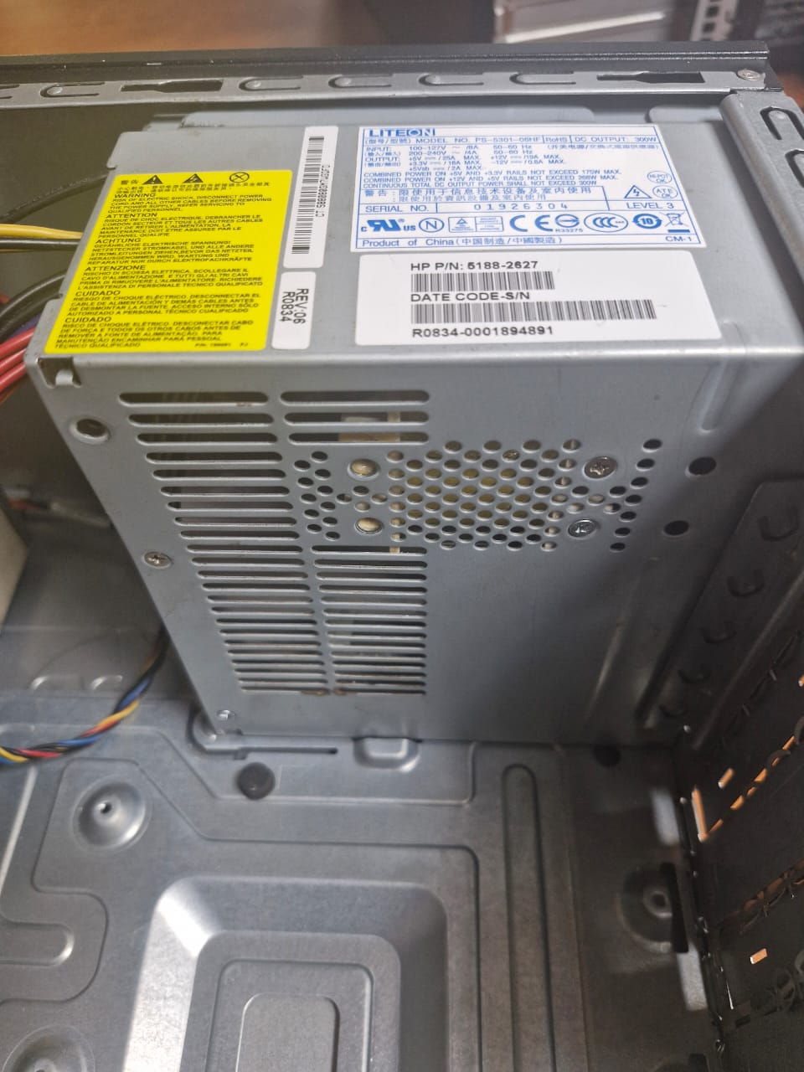

The power supply unit (PSU) within a computer system plays a pivotal role in converting alternating current (AC) from a wall outlet into direct current (DC) voltages essential for powering internal components. At the digital logic level, the PSU incorporates sophisticated circuitry to ensure stable and reliable power delivery. This includes voltage regulation mechanisms to maintain consistent DC output voltages despite fluctuations in input voltage or load, as well as current limiting and overvoltage protection to safeguard components from potential damage. Utilizing digital control circuits like pulse-width modulation (PWM) controllers and feedback loops, modern power supplies optimize output voltages efficiently, enhancing overall system performance and reliability.

Moreover, the digital logic within the power supply implements advanced safety features such as overcurrent protection (OCP), short circuit protection (SCP), and overtemperature protection (OTP) to mitigate risks of electrical hazards. These safety mechanisms operate seamlessly to safeguard both the PSU and connected components, ensuring uninterrupted operation and system integrity. Furthermore, the integration of digital communication interfaces allows for enhanced monitoring and control of PSU parameters, facilitating real-time adjustments and system optimization. In essence, at the digital logic level, the power supply unit serves as an orchestrator, regulating power delivery and implementing safety measures to uphold the stability and efficiency of the entire computer system.

# PERIPHERAL PORTS

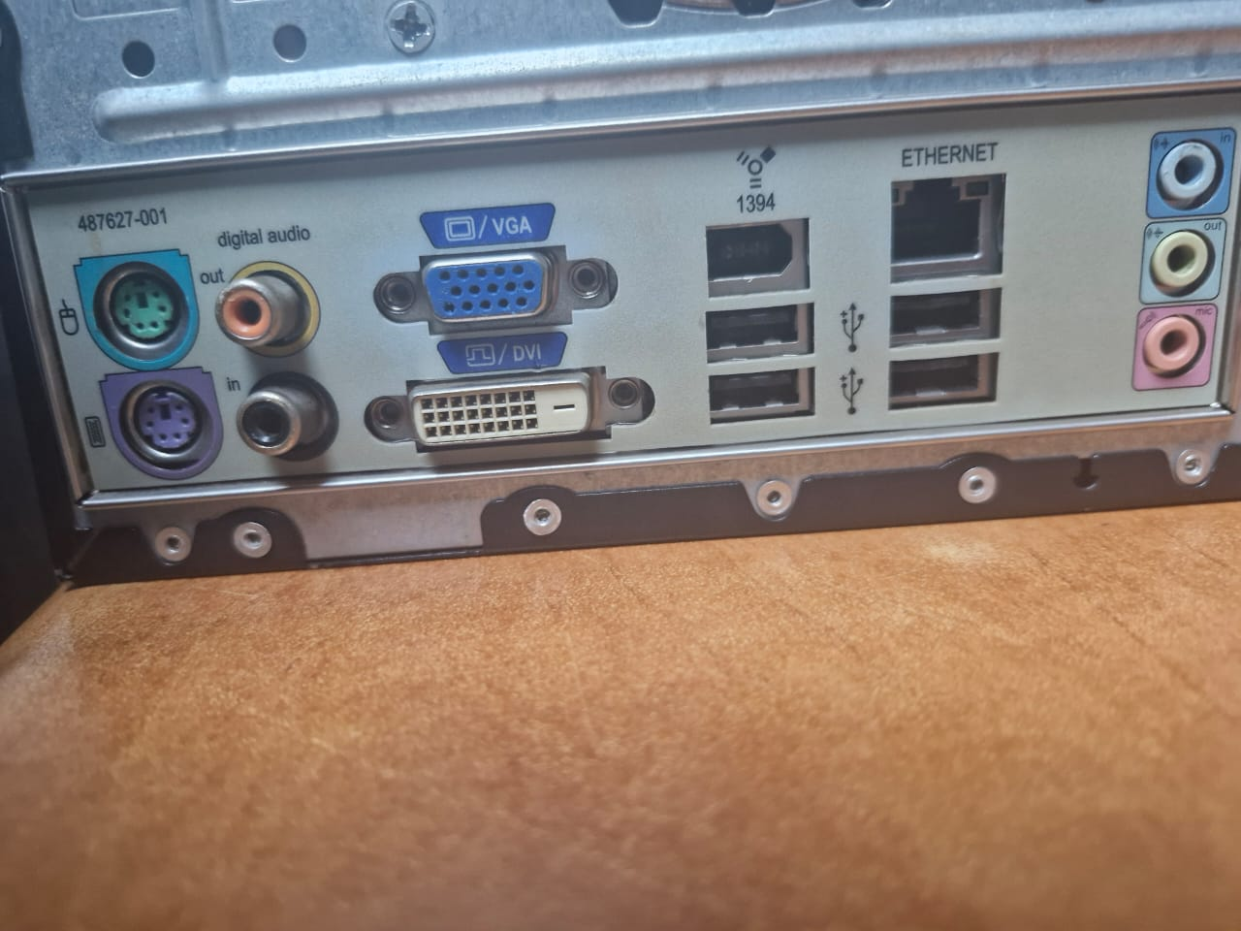

At the digital logic level, peripheral ports serve as crucial gateways for facilitating communication between a computer system and external devices. These ports encompass a diverse array of interfaces, including USB, HDMI, DisplayPort, Ethernet, audio jacks, and Thunderbolt, each designed to cater to specific connectivity needs. Within each port, sophisticated digital logic circuitry performs vital functions such as signal conditioning, voltage regulation, data encoding/decoding, error checking, and protocol handling. This ensures reliable and efficient communication between the computer and peripheral devices, optimizing compatibility and data integrity. Moreover, the evolution of peripheral ports has witnessed significant advancements to support faster data transfer rates, higher resolutions, and additional functionalities. USB ports, for instance, have undergone multiple revisions, offering increased speeds and improved power delivery capabilities, while HDMI and DisplayPort standards have evolved to support enhanced multimedia experiences. Through continuous adaptation and refinement, the digital logic within peripheral ports ensures compatibility, reliability, and performance across different generations of devices and peripherals, thereby sustaining seamless connectivity and functionality within the computer system.

Furthermore, the integration of digital logic within peripheral ports enables efficient power management, protocol interpretation, and error correction mechanisms. Each port operates with its own set of protocols, data transfer rates, and power delivery specifications, meticulously managed by the digital circuitry within. As a result, peripheral ports not only facilitate the transfer of data and multimedia content but also provide power to connected devices and manage power delivery based on individual requirements. With advancements in technology, peripheral ports have become indispensable components in modern computing environments, enabling users to connect a wide range of external devices seamlessly. Whether it's transferring data, outputting multimedia content, or providing network connectivity, peripheral ports, driven by digital logic, play a vital role in enhancing the overall functionality and versatility of computer systems.

# PORTS

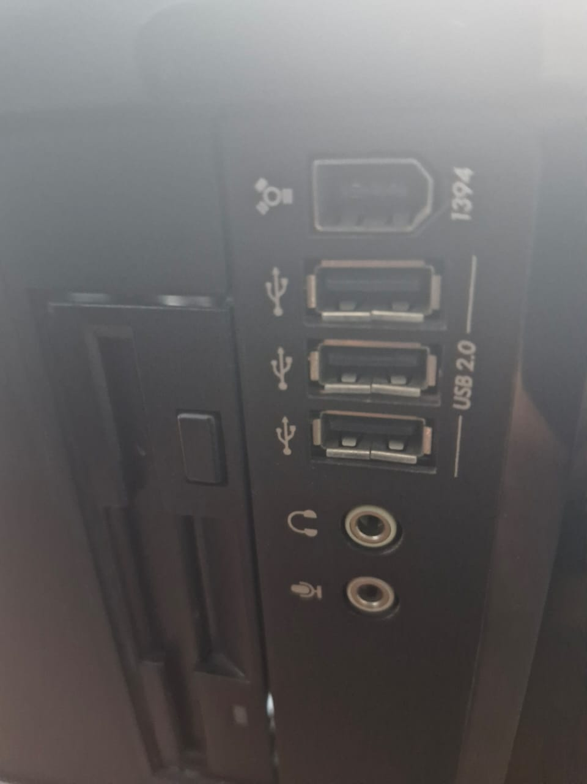

At the digital logic level, ports within a computer system serve as vital conduits for managing signal processing, protocol interpretation, and power delivery, ensuring seamless communication between internal components and external devices. These ports encompass a wide range of interfaces, including both internal connectors on the motherboard and external ports on the computer's case or back panel. Whether it's transmitting data between storage drives and the motherboard through SATA connectors or facilitating audio/video output to external displays via HDMI and DisplayPort, the digital logic within ports orchestrates various functions to optimize signal integrity and reliability. Additionally, power management functionalities within ports regulate voltage and current levels to ensure that connected devices receive adequate power for operation and charging, enhancing overall system stability and functionality.

Furthermore, the evolution of ports has seen significant advancements to accommodate higher data transfer rates, increased power delivery capabilities, and additional functionalities. From the development of new port standards such as USB 3.0 and Thunderbolt 3 to the introduction of features like reversible connectors and improved durability, manufacturers continually innovate to meet the evolving needs of users. With each iteration, digital logic within ports adapts to incorporate faster data transfer technologies, higher-resolution display standards, and more versatile connectivity options, ensuring compatibility, reliability, and performance across different generations of devices and peripherals. In essence, ports, driven by digital logic circuitry, play an indispensable role in facilitating communication, data transfer, power delivery, and peripheral connectivity within a computer system, thereby optimizing overall system functionality and user experience.